Enterprise Network Design & Implementation Summary

PLAN
Three zones were initially laid out: the internal LAN for our five internal subnets (blue squares), our DMZ subnet (blue circle), and on the other side of our firewall router (pastel), the external network to reach the WAN/ISP. Our choice of fixed subnets was also a choice in our initial plan to have better control over the routes and to better implement AAA.
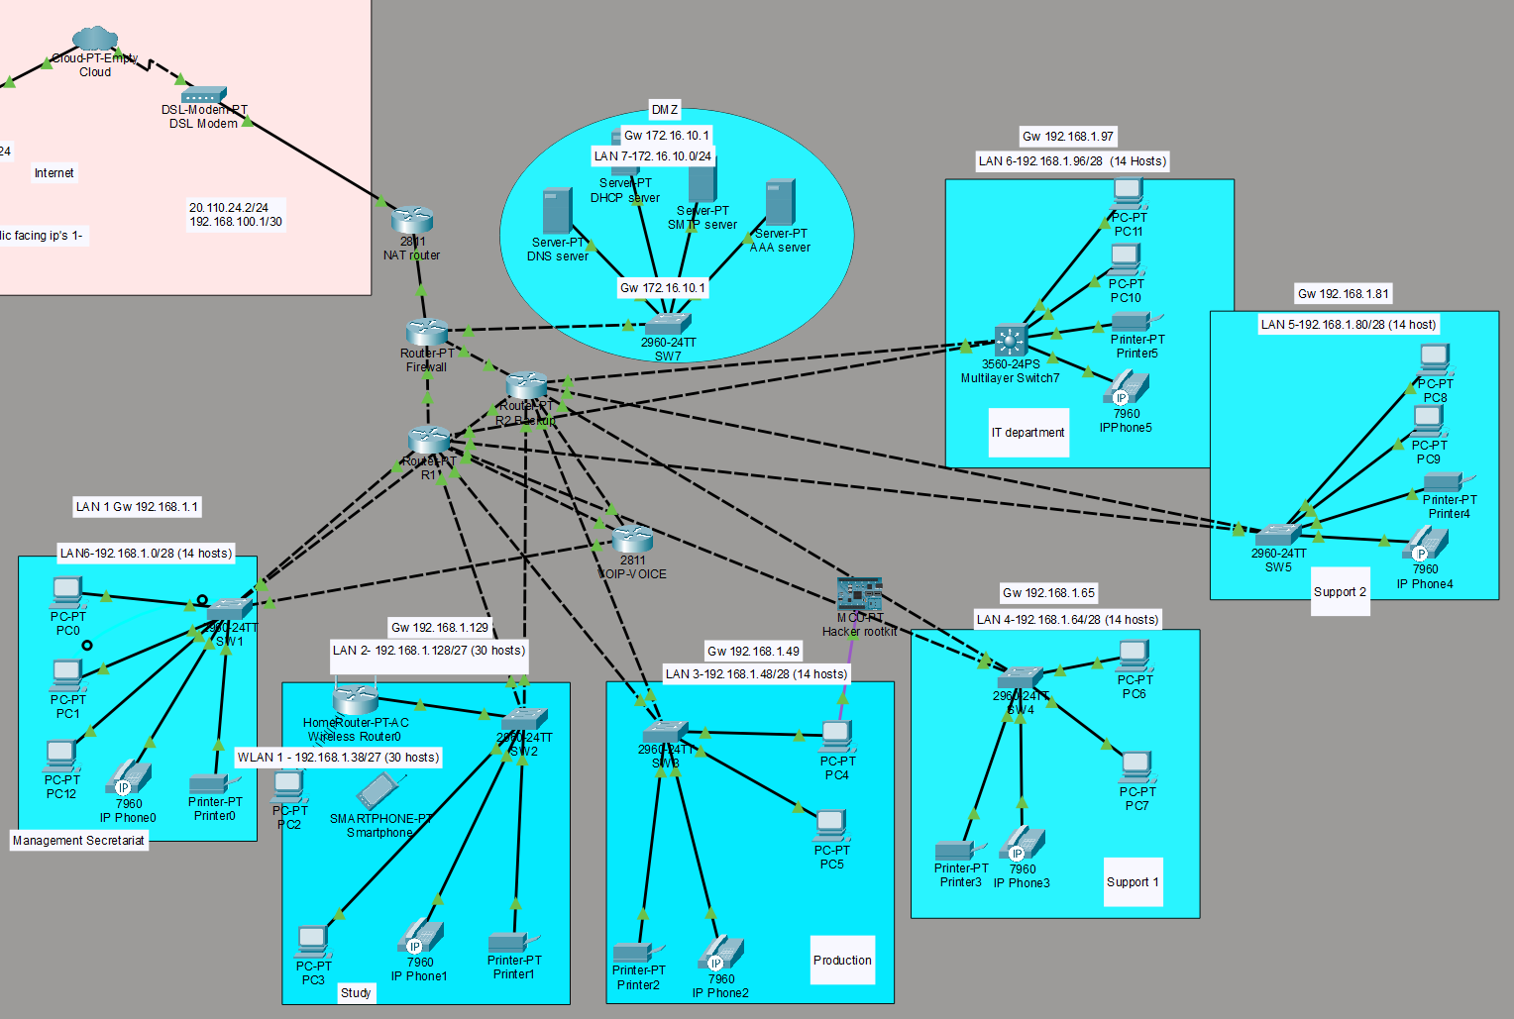

1. Network Architecture Overview
• Router1 (R1) and Router2 (R2) configured for gateway redundancy using HSRP.
• Firewall deployed as edge device performing NAT (PAT overload).
• SOHO/ISP router used as upstream gateway.
• Multiple VLSM-based LAN segments implemented.
- Added 2811 Router to handle voice, as our original network architecture did not handle VOIP connections, (see modify chapter)
- Should discuss wireless router as well. Do we want a secure and a guest connection? Or just the secure one that is set-up inside the router?

2. Subnet Design (VLSM)
Implemented Subnets:
• 192.168.1.0/28 (Gateway VIP: 192.168.1.1)
• 192.168.1.48/28 (Gateway VIP: 192.168.1.49)
• 192.168.1.64/28 (Gateway VIP: 192.168.1.65)
• 192.168.1.80/28 (Gateway VIP: 192.168.1.81)
• 192.168.1.96/28 (Gateway VIP: 192.168.1.97)
• 192.168.1.128/27 (Gateway VIP: 192.168.1.129)
- We didn’t annotate the Router subnet design
- In the reality the subnet 192.168.1.16/28 didn’t work in the setup, this is discussed further in modify chapter.

3. HSRP Redundancy Implementation
HSRP configured on all LAN interfaces between R1 and R2.
Key Commands Used:
standby <group> ip <virtual-ip>
standby <group> priority <value>
standby <group> preempt
show standby brief
Result: Automatic gateway failover without manual routing changes.

4. Firewall Configuration & NAT
Inside Interface: 172.16.10.1/24 (ip nat inside)
Outside Interface: 192.168.100.2/30 (ip nat outside)
PAT Configuration:
ip nat inside source list NAT_INSIDE interface FastEthernet1/0 overload
Verification Commands:
show ip nat translations
show ip nat statistics

5. Static Routing Design
Default Route (Firewall → ISP):
ip route 0.0.0.0 0.0.0.0 192.168.100.1
Internal Routes (Firewall → Internal Router):
ip route 192.168.1.0 255.255.255.0 10.1.1.2
Routing Verification:
show ip route
show ip route static

6. ACL Implementation
Extended ACL 100 applied inbound on firewall interfaces.
Example:
access-list 100 permit ip 192.168.1.0 0.0.0.255 any
access-list 100 deny ip any any
Applied using:
ip access-group 100 in

7. DMZ
Besides the internal and external configuration of our topology, we had planned a DMZ subnet to house the externally-facing services to the open Internet. This was used to protect our organization’s LAN from untrusted traffic.
Inside we planned to house also our servers, to give an additional layer of protection for them as well.

8. Final Network Behavior
• Automatic gateway failover via HSRP.
• Internal traffic routed correctly without NAT.
• External traffic NATed at firewall only.
• ISP return routing properly configured.
• No routing loops or asymmetric routing.
- Periphery devices (ie printers) were allocated the last available address in each subnet to always know how to find them.
- SSH was priviledged over Telnet in the design, with Telnet being disabled on routers and switches to avoid common breaches.

IMPLEMENTATION
Within our enterprise we identified and implemented secure configuration baselines for most technology. If given more time, we could have hardened further by implementing more hardening measures on the PCs, periphery devices. However, given our week, we focused on implementation on routers, switches, and servers for the most part. Our hardening measures can mostly be resumed as following:
- Anti-malware capabilities
- Access control, to include user accounts and authentication credentials
- Encryption
- Logging
- Least privilege
- Leveraging hardware security capabilities when possible
- Disabling of unused services, applications, and functionality
- Network connections
- Automatic session locking
- Removal of default accounts or names
Within the choice of our routers and switches, some of the commands were not fully implemented and count as some lessons learned about the choices of routers and switches.
With all these implementations, care was taken to save from running-config to startup-config.
We did not do baseline analysis as this topology didn’t have “real” traffic, but it was thought of in the case of a real-life scenario.

3. Redundancy Implementation
HSRP (Hot Standby Router Protocol)
Implemented between Router1 and Router2 for gateway redundancy.
Example Configuration (Router1)
interface fa2/0
ip address 192.168.1.51 255.255.255.240
standby 1 ip 192.168.1.49
standby 1 priority 110
standby 1 preempt
Key Commands Used
show standby brief
standby <group> ip <virtual-ip>
standby <group> priority <value>
standby <group> preempt
Purpose:
- Provides automatic gateway failover
- Prevents manual route changes during router failure

4. Firewall Configuration
Inside / Outside Interfaces
interface FastEthernet0/0
ip address 172.16.10.1 255.255.255.0
ip nat inside
interface FastEthernet1/0
ip address 192.168.100.2 255.255.255.252
ip nat outside

5. NAT Configuration
PAT (Overload)
ip nat inside source list NAT_INSIDE interface FastEthernet1/0 overload
NAT Access List
ip access-list standard NAT_INSIDE
permit 192.168.1.0 0.0.0.255
permit 192.168.2.0 0.0.0.255
permit 172.16.10.0 0.0.0.255
Verification Commands
show ip nat translations
show ip nat statistics
Purpose:
- Allow internal subnets to access ISP
- Perform address translation only when exiting outside interface

6. Static Routing
Default Route (Firewall → ISP)
ip route 0.0.0.0 0.0.0.0 192.168.100.1
Internal Routes (Firewall → Router1 or Router2)
ip route 192.168.1.0 255.255.255.0 10.1.1.2

7. ACL Implementation
Used to control traffic entering firewall.
access-list 100 permit ip 10.1.1.0 0.0.0.3 any
access-list 100 permit ip 192.168.1.0 0.0.0.255 any
access-list 100 deny ip any any
Applied to interface:
interface fa7/0
ip access-group 100 in

MONITOR
Ideally all the routers and switches would at minima have commands like the following:
Router(config)# login quiet-mode access-class myacl
Router(config)# login block-for 100 attempts 2 within 100
Router(config)# login on-failure log
Also, logging failures for key infrastructure should be saved in an external file. Care should be taken to choose the right ones, because logging all attempts could slow down operations.
As the objective of this activity was to build a topology, we did not spend time in developing an on-going monitoring of future activities. Ideally there would also be updates to baseline studies to monitor the chokepoints of expanding operations.
That being said, we did add a hacking computer + hacker rootkit during our testing phases to monitor discovery hacks and man-in-the-middle, to try and harden our system ACL to specifically target these types of scenarios.

MODIFY
Multiple troubleshooting journeys were undertaken while implementing our topology.
* Implementation of the AAA server. This caused some of our passwords to fail, and routes had to be reconfigured.
* VOIP. The routers that we picked in the original topology do not support telephony commands, despite trying several work arounds. In the end, we added an additional router that could be configured to meet the demands of the VOIP. This seemed a logical fix to a working enterprise configuration instead of downing the infrastructure and restarting over. All VOIP was configured to Vlan 20.
* Subnetting. For some reason, our subnet 192.168.1.16/27 subnet for the study did not implement properly, despite troubleshooting. So we decided to apply a new subnet of 192.168.1.128/27 (end of the list for internal subnetting) to work around. That seemed to have fixed the problem.
*ACL
*VLAN
Identified and resolved:
• Incorrect HSRP virtual IP assignments
• Routing loops between firewall and SOHO router
• Inactive static routes due to unreachable next-hop
• NAT translating internal-to-internal traffic
• Interface up/down link issues
Some command prompts could not be undertaken, but were thought of in the planning and implementation phase, these include (as well as others listed in monitoring):
- logout automatic after 5 minutes
- security passwords minimum length
- automatic patches
- firewall: disable key words
8. Troubleshooting Techniques Used
Routing
show ip route
show ip route static
show run | include ^ip route
Interface Status
show ip interface brief
show interface <interface>
ARP
show arp
Connectivity
ping <ip>
traceroute <ip>
Access-list
Show access-list
The use of AI was used in the case of several attempts at troubleshooting failures, expanding our ability to think of additional techniques in real time to test on our network.

